10.1 Radicals and Radical Functions

Definitions of the following terms.
- Square root of a number-is the inverse operation of squaring that number
- Radical expression-an expression within the symbol. This symbol is radical symbol and the number within it is called radicand. Any expression within the radical symbol.
- Radicand-The number under the (radical) symbol. That is, a number which is having its square root taken (or cube root, 4th root, 5th root, nth root, etc.)

- Principal square root-The unique nonnegative square root of a nonnegative real number. For example, the principal square root of 9 is 3, although both and 3 are square roots of 9.
- Negative square root- is one of two square roots of a positive number. For the number 25, its negative square root is -5 because (-5)^2 = 25.

Practice 1 on page 587 in the multimedia textbook, below.
Simplify. Assume all variables represent positive numbers.

- $\sqrt{49}$ = $\sqrt{7*7}=7$
- $\sqrt{\frac{0}{1}}$= 0
- $\sqrt{\frac{16}{81}}=\frac{\sqrt{16}}{\sqrt{81}}=\frac{4}{9}$
- $\sqrt{0.64}=\frac{\sqrt{64}}{\sqrt{100}}=\frac{8}{10}=0.8$
- $\sqrt{z^{8}}=z^{8*\frac{1}{2}}=z^{4}$
- $\sqrt{16b^{4}}=\sqrt{16}*\sqrt{b^{4}}=4b^{2}$
- $-\sqrt{36}=-6$
- $\sqrt{-36}=\sqrt{-1}*\sqrt{36}=6i$

Explain in your own words why the square root of a negative number is not a real number
-Negative numbers don't have real square roots since a square is either positive or 0

Explain in your own words the difference between a perfect square and an irrational number
-Irrational numbers are square roots of non-perfect squares. Only the square roots of square numbers are rational. Similarly Pi (π) is an irrational number because it cannot be expressed as a fraction of two whole numbers and it has no accurate decimal equivalent

Practice 2
Using your calculator, approximate the following to three decimal places.

√45 ≈ 6.708 (3 d.p)

Objective 3. Finding cube roots
Cube Root – The cube root of a number is a special value that, when used in a multiplication three times, gives that number.

Practice 3
Find the cube roots
- $\sqrt[3]{-1 }=-1$
- $\sqrt[3]{27}=-3$
- $\sqrt[3]{27/64}=\frac{\sqrt[3]{27}}{\sqrt[3]{64}}=3/4$
- $\sqrt[3]{x^{12}}=x^{12*\frac{1}{3}}=x^{4}$
- $\sqrt[3]{-8x^{3}}=-2x$

Objective 4. Finding nth roots
In each of the following, write “yes” if the root is real and “no” if it is not.
- $\sqrt{-16}=NO$
- $-\sqrt{16}=YES$
- $\sqrt[3]{27}=YES$
- $\sqrt{-9}=NO$
- $\sqrt[4]{-16}=YES$
- $\sqrt[6]{{\left(-8\right)}^{2}}=YES$

Practice 4
Simplify the following expressions
- $\sqrt[4]{10000}={10}^{4*\frac{1}{4}}=10$
- $\sqrt[5]{-1}=-1$
- $-\sqrt{81}=-9$
- $\sqrt[4]{-625}=\sqrt[4]{625}*\sqrt[4]{-1}=5\sqrt[4]{-1}$
- $\sqrt[3]{27x^{9}}=3^{\frac{1}{3}*3}*x^{9*\frac{1}{3}}=3x^{3}$

Practice 5: simplify

- $\sqrt{{\left(-4\right)}^{2}}=\sqrt{16 }=4$
- $\sqrt{x^{14}}=x^{14*\frac{1}{2}}=x^{7}$
- $\sqrt[4]{{\left(x+7\right)}^{4}}={\left(x+7\right)}^{4*\frac{1}{4}}=x+7$
- $\sqrt[3]{{\left(-7\right)}^{3}}=-7^{3*\frac{1}{3}}=-7$
- $\sqrt[5]{{\left(3x-5\right)}^{5}}={\left(3x-5\right)}^{5*\frac{1}{5}}=\left(3x-5\right)$
- $\sqrt{49x^{2}}={(7x)}^{2*\frac{1}{2}}=7x$
- $\sqrt{x^{2}+16x+64}=\sqrt{{\left(x+8\right)}^{2}}=x+8$

Graphing Calculator
Practice Problem 1:
Use your calculator to find each of the following. Round each answer to the nearest hundredth.
- $\sqrt{32}=5.66$
- $\sqrt[3]{32}=3.17$
- $\sqrt[4]{32}$ =2.38
- $\sqrt[6]{32}=1.78$

Use the choices below to fill in each blank. Not all choices will be used.
1. In the expression, the n is called the __index______, the is called the ____radical sign____, and a is called the ____radicand____
2. If is the positive square root of a, , then ___-$\sqrt{a}$______ is the negative square root of a.
3. The square root of a negative number ___is not______ a real number.
4. Numbers such as 1, 4, 9, and 25 are called perfect ____squares____, whereas numbers such as 1, 8, 27 and 125 are called perfect _____cubes___.

10.2 Rational Exponents
Definition of a1 /n – This is the nth root of a value a.

Practice 1
Use radical notation to write the following. Simplify if possible.
- 36^1/2 = $\sqrt{36}$
- 1000^1/3 =$\sqrt[3]{1000}$
- X^1/3 = $\sqrt[3]{x}$
- 1^1/4 = $\sqrt[4]{1}$
- -64^1/2 = $\sqrt{-64}$
- (125x^9)^1/3 =$\sqrt[3]{125x^{9}}$
- 3x^1/4 =$3\sqrt[4]{x}$

Objective 2
Understanding the meaning of a^ (m/n)

Definition of a^(m/n)-
is the nth root of a value a that is raised to power m. i.e . =>

Practice 2
Use radical notation to write the following. Simplify if possible

Solutions
We use the rule of indices that :

- 16^3/2 = $\sqrt{{16}^{3}}$
- -1^3/5 = $\sqrt[3]{-1^{3}}$
- –(81)^3/4 = $-\sqrt[4]{{81}^{3}}$
- (1/25)^3/2 = $\sqrt{{\left(\frac{1}{25}\right)}^{3}}$
- (3x+2)^5/9 = $\sqrt[9]{{\left(3x+2\right)}^{5}}$

Objective 3

Understanding the meaning of a^(-m/n )

Definition of a^(-m/n)
- This is the reciprocal of ‘a’ raised to power ‘m/n’

Practice 3
Write each expression with a positive exponent; then simplify

- 9^(-3/2)
Solution
=$\frac{1}{{\left(\sqrt{9}\right)}^{3}}=\frac{1}{27}$

- (-64)^-2/3

Solution
=$-\frac{1}{{\left(\sqrt[3]{64}\right)}^{2}}$

=1/16

Objective 4
Using Rules for Exponents to Simplify Expressions

- Product rule for exponents:
- Power rule for exponents:
- Power rules for products and quotients:
- Quotient rule for exponents:
- Zero exponent:
- Negative exponent : 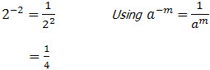

Practice 4
Use properties of exponents to simplify.
- y^2/3*y^8/3
solution
y^(2/3+8/3)
=y^10/3

- x^3/5*x^1/4
solution
=x^(3/5+1/4)
=x^17/20

- $\frac{9^{\frac{2}{7}} }{9^{\frac{9}{7}}}$
$$solution$$
$\frac{1}{9^{\frac{9}{7}-\frac{2}{7}}}$ =1/9
- $b^{\frac{4}{9}}*b^{-2/9}$=
$$solution$$
=b^(4/9-2/9)
= b^2/9

- $\frac{{\left(3x^{\frac{1}{4}}y^{-\frac{2}{3}}\right)}^{4}}{x^{4}y}=\frac{81}{x^{3}y^{11/3}}$

Practice 5
Multiply.

- $x^{3/5}(x^{1/3}-x^{2})$
$$solution$$
$$x^{\frac{3}{5}}\sqrt[x]{x}-x^{\frac{3}{5}}\left(x^{2}\right)$$

$$=x^{14/15}-x^{13/5}$$

- $(x^{1/2}+6)(x^{1/2}-2)$
Solution
=$(\sqrt{x}+6)(\sqrt{x}-2)$
=$x+4\sqrt{x}-12$

Study Objective 5,
“Using Rational Exponents to Simplify Radical Expressions

Practice 7
Use rational exponents to simplify. Assume variables represent positive numbers.
- $\sqrt{x^{3}}=x^{3*\frac{1}{2}}=x^{3/2}$
- $\sqrt[4]{36}=6^{2*\frac{1}{4}}=\sqrt{6}$
- $\sqrt[8]{a^{4}b^{2}}= b^{\frac{1}{4}}\sqrt{a}$

Practice 8
Use rational exponents to write each of the following as a single radical
- $\sqrt[3]{x}*\sqrt[4]{x}$
$$solution$$
$$x^{\frac{1}{3}}*x^{\frac{1}{4}}$$
$$=\sqrt[12]{x^{7}}$$

- $\frac{\sqrt[3]{y}}{\sqrt[5]{y}}$
$$solution$$
$$y^{\frac{2}{15}}= \sqrt[15]{y^{2}}$$

- $\sqrt[3]{5}*\sqrt{3}$ $=\sqrt[3]{5}\sqrt{3}$

Graphing Calculator
Practice Problem 1:
Use your calculator to find each of the following. Round each answer to the nearest hundredth
- $12^{\frac{4}{3}}=27.27$
- 30^2/5 = 3.90
- $\sqrt[3]{36}=3.30$
- $\sqrt[3]{36^{2}}=10.90$
Vocabulary, Readiness & Video Check
Answer each true or false
- TRUE
- FALSE
- TRUE
Fill in the blank with the correct choice
- Add
- Multiply
- Subtract

Section 10.3 Simplifying Radical Expressions
Objective 1
The Product Rule
Product Rule for Radicals -You can ONLY multiply any two radicals that have the same indices (degrees of a root) together.
PRACTICE1
Multiply.
- $\sqrt{5}*\sqrt{7}$
$$= \sqrt{5*7}=\sqrt{35}$$

- $\sqrt{13}*\sqrt{2}$
$$=\sqrt{13*2}=\sqrt{26}$$

- $\sqrt[4]{125}*\sqrt[4]{5}$
=$\sqrt[4]{125*5}=5$

- $\sqrt[3]{5y}*\sqrt[3]{3x^{2}}$
=$\sqrt[3]{5y*3x^{2}}=\sqrt[3]{15x^{2}y}$

- $\sqrt{\frac{5}{m}}*\sqrt{\frac{t}{2}}$
=$\sqrt{\frac{5}{m}*\frac{t}{2}}$
=$\sqrt{\frac{5t}{2m}}$

Objective 2,

“Using the Quotient Rule

Practice 2
Use the quotient rule to simplify
- $\sqrt{\frac{36}{49}} =\frac{6}{7}$
- $\sqrt{\frac{z}{16}}$ = $\frac{\sqrt{z}}{4}$
- $\sqrt[3]{\frac{125}{8}}$ =$\frac{\sqrt[3]{125}}{\sqrt[3]{8}}$ =5/2
- $\sqrt[4]{\frac{5}{81x^{8}}}$ =$\frac{\sqrt[4]{5}}{\sqrt[4]{81x^{8}}}=\frac{\sqrt[4]{5}}{3x^{2}}$
Objective 3,
“Simplifying Radicals

Write out the perfect squares up to below 12^2

1^2 = 1*1 =1
2^2= 2*2= 4
3^2=3*3=9
4^2=4*4=16
5^=5*5=25
6^2=6*6=36
7^2=7*7=49
8^2=8*8=64
9^2=9*9=81
10^2=10*10=100
11^2=11*11=121
12^2=12*12=144

Write out the perfect cubes up to 5^3

1^3= 1*1*1=1
2^3=2*2*2=8
3^3=3*3*3=27
4^3=4*4*4=64
5^3=5*5*5=125

Write out the perfect fourth powers up to 4^4

1^4=1*1*1*1=1
2^4=2*2*2*2=16
3^4=3*3*3*3=81
4^4=4*4*4*4=256

Practice 3
Simplify the following.
- $\sqrt{98}$
=$\sqrt{2}*\sqrt{7^{2}}=7\sqrt{2}$

- $\sqrt[3]{54}$
= $\sqrt[3]{2}*\sqrt[3]{3^{3}}=3\sqrt[3]{2}$

- $\sqrt{35}$
= $\sqrt{7*5}=\sqrt{35}$

- $\sqrt[4]{243}$
= $\sqrt[4]{3^{5}}=3\sqrt[4]{3}$

Practice 4
Use the product rule to simplify.

- $\sqrt{36z^{7}}=\sqrt{36}*\sqrt{z^{7}}=6\sqrt{z^{7}}$

- $\sqrt[3]{32p^{4}q^{7}}=\sqrt[3]{2^{3}}*\sqrt[3]{4p^{4}q^{7}}=2\sqrt[3]{4p^{4}q^{7}}$

- $\sqrt[4]{16x^{15}}=\sqrt[4]{2^{4}}*\sqrt{x^{15}}=2\sqrt[4]{x^{15}}$

Practice 5
Use the quotient rule to divide and simplify.
- $\frac{\sqrt{80}}{\sqrt{5}}$ = $\frac{2^{2}\sqrt{5}}{\sqrt{5} }=4$
- $\frac{\sqrt{98z}}{3\sqrt{2}}=\frac{7\sqrt{2}\sqrt{z}}{3\sqrt{2}}= \frac{7\sqrt{z}}{3}$
- $\frac{5\sqrt[3]{40x^{5}y^{7}}}{\sqrt[3]{5y}}$ = $10y^{2}x^{\frac{5}{3}}$
- $\frac{3\sqrt[5]{64x^{9}y^{8}}}{\sqrt[5]{x^{-1}y^{2}}}$ = $6x^{2}y^{\frac{6}{5}}\sqrt[5]{2}$

Objective 4,
“Using the Distance and Midpoint Formulas,”

Distance Formula = 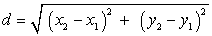

Solution
D=$\sqrt{{\left(-2+3\right)}^{2}+{\left(3-7\right)}^{2}}$ = $\sqrt{17}$
Exact distance = $\sqrt{17}$
Approximate distance = 4.123

Midpoint Formula = $(\frac{x1+x2}{2},\frac{y1+y2}{2})$

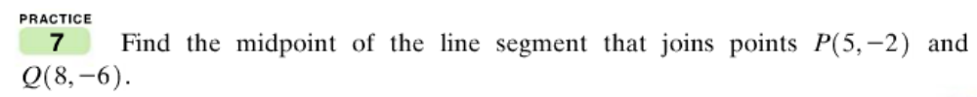

Solution
$$\left(\frac{x1+x2}{2},\frac{y1+y2}{2}\right)=(\frac{5+8}{2},\frac{-2-6}{2})$$
=$(6.5,-4)$

Vocabulary, Readiness & Video Check
Answers to blank spaces
- Midpoint, point
- Distance
- Distance
- Midpoint

Section 10.4 Adding, Subtracting, and Multiplying Radical Expressions
Like Radicals - are radicals that have the same root number AND radicand (expression under the root).
Give an example of two terms that are “like radicals.” -

Practice 1
Add or subtract
- $3\sqrt{17}+5\sqrt{17}$

$$solution$$
Adding the like terms we have
$$3\sqrt{17}+5\sqrt{17}=8\sqrt{17}$$

- $7\sqrt[3]{52}-12\sqrt[3]{52}= -5\sqrt[3]{52}$

- $3\sqrt{2}+5\sqrt[3]{2}$
Solution
There are unlike radicals thus sum =$3\sqrt{2}+5\sqrt[3]{2}$

Practice 2
Add or subtract.
- $\sqrt{24}+3\sqrt{54}$ = $2\sqrt{6}+9\sqrt{6}$=$11\sqrt{6}$

- $\sqrt[3]{24}-4\sqrt[3]{81}+\sqrt[3]{3}$
$$solution$$
= $2\sqrt[3]{3}-12\sqrt[3]{3}+\sqrt[3]{3}$
$$= -\sqrt[93]{3}$$

- $\sqrt{75x}-3\sqrt{27x}+\sqrt{12x}$

Solution
=$5\sqrt{3x}-9\sqrt{3x}+2\sqrt{3x}$
=$= -2\sqrt{3x}$

- $\sqrt{40}+\sqrt[3]{40}=2\sqrt{10}+2\sqrt[3]{5}$

- $\sqrt[3]{81x^{4}}+\sqrt[3]{3x^{4}}= 4\sqrt[3]{3x^{4}}$

Practice 3
Add or subtract as indicated.
- $\frac{\sqrt{28}}{3}-\frac{\sqrt{7}}{4}$
Solution
=$\frac{2\sqrt{7}}{3}-\frac{\sqrt{7}}{4}$ = $\frac{5\sqrt{7}}{12}$
- $\sqrt[3]{\frac{6y}{64}}+3\sqrt[3]{6y}$ =$\frac{13\sqrt[3]{6y}}{4}$

Objective 2
Multiplying Radical Expressions
- $\sqrt{5}(2+\sqrt{15})$
$$solution$$
$$2\sqrt{5}+\sqrt{125}$$
=$2\sqrt{5}+5\sqrt{3}$

- $(\sqrt{2}-\sqrt{5})(\sqrt{6}+2)$
Solution
Multiplying
$$\sqrt{2}\left(\sqrt{6}+2\right)-\sqrt{5}(\left(\sqrt{6}+2\right))$$
$$=2\sqrt{3}+2\sqrt{2}-\sqrt{30}-2\sqrt{5}$$

- ${\left(\sqrt{6}-3\right)}^{2}$
$$solution$$
=$\left(\sqrt{6}-3\right)\left(\sqrt{6}-3\right)$
=$15-6\sqrt{6}$

- $(\sqrt{5x}+3)( \sqrt{5x}-3)$
Solution
=$\sqrt{5x}\left(\sqrt{5x}-3\right)+3(\sqrt{5x}-3)$

- $(3\sqrt{z}-4)(2\sqrt{z}+3)$
Solution
$$3\sqrt{z}\left(2\sqrt{z}+3\right)-4)(2\sqrt{z}+3)$$
$$=6z+\sqrt{z}-12$$

- ${\left(\sqrt{x+2}+3\right)}^{2}$
Solution
$$\left(\sqrt{x+2}+3\right)\left(\sqrt{x+2}+3\right)$$
=$x+6\sqrt{x+2}+11$

Complete the Vocabulary, Readiness & Video Check
Answers
- Unlike radical terms
- Like radical terms
- Like radical terms
- Unlike radical terms

Simplify
- $7\sqrt{3}$
- $8\sqrt{7}$
- $7\sqrt{x}$
- $2\sqrt{y}$
- $8\sqrt[3]{x}$
- $9\sqrt[3]{z}$

Section 10.5 Rationalizing Denominators and Numerators of Rational Expressions
What does rationalizing the denominator mean?
-The process by which a fraction is rewritten so that the denominator contains only rational numbers

Practice 1, 2 and 3
Rationalize the denominator of each expression.

- a)$5/\sqrt{3}$
Solution
$$\frac{5\sqrt{3}}{\sqrt{3}*\sqrt{3}}=\frac{5\sqrt{3}}{3}$$
1.b) $\frac{3\sqrt{25}}{\sqrt{4x}}$
Solution
$$\frac{15\sqrt{4x} }{4x}=\frac{15\sqrt{x}}{2x}$$

1.c) $\sqrt[3]{\frac{2}{9}}$ = $\sqrt[3]{\frac{2}{9}}$

- $\sqrt{\frac{3z}{5y}}$
Solution

=$\sqrt{\frac{3z}{5y}}=\frac{\sqrt{3z}}{\sqrt{5y}}=\frac{\sqrt{3z}*\sqrt{5y}}{5y}$
=$\frac{\sqrt{15yz}}{5y}$
- $\frac{\sqrt[3]{z^{2}}}{\sqrt[3]{27x^{4}}}$
Solution
= $\frac{z^{\frac{2}{3}}}{3x^{\frac{4}{3}}}$

Study Objective 2,

“Rationalizing Denominators Having Two Terms

- What is a conjugate? – is what is formed by changing the sign between two terms in a binomial. For instance, the conjugate of x + y is x – y

- Why are conjugates important? - We cannot just go around and change the value of expressions so that we can get rid of radicals. There needs to be some logical or practical reason. For instance, multiplying an expression by its conjugate is very useful when simplifying certain fraction
- What is the conjugate of √5 − 2? = $\sqrt{5}$+2

- Multiply √5 − 2 by its conjugate. Show your work below

Solution
$$\left(\sqrt{5}-2\right)\left(\sqrt{5}+2\right)$$
=$\sqrt{5}\left(\left(\sqrt{5}+2\right)\right)-2\sqrt{5}(\left(\sqrt{5}+2\right)$
=1

Practice 4
Rationalize the denominator. Show your work.
4a. $\frac{5}{3\sqrt{5}+2}$
Solution
$$\frac{5\left(3\sqrt{5}-2\right)}{\left(3\sqrt{5}+2\right)\left(3\sqrt{5}-2\right)}$$
$$=\frac{15\sqrt{15}-10}{41}$$
4b. $\frac{\sqrt{2}+5}{\sqrt{3}-\sqrt{5}}$
Solution
$$\frac{(\sqrt{2}+5 )\left(\sqrt{3}+\sqrt{5}\right)}{(\sqrt{3}-\sqrt{5})(\sqrt{3}+\sqrt{5})}$$
= $-\frac{(\sqrt{2}+5 )\left(\sqrt{3}+\sqrt{5}\right)}{2}$
4c. $\frac{3\sqrt{x}}{2\sqrt{x}+\sqrt{y}}$
Solution
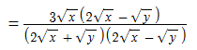
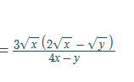

Complete the Vocabulary, Readiness & Video Check
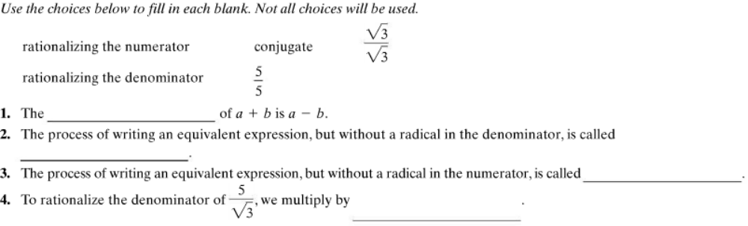
Answers
- Conjugate
- Rationalizing the denominator
- Rationalizing the numerator
- $\frac{\sqrt{3}}{\sqrt{3}}$

Objective 1

Solving Equations that Contain Radical Expressions

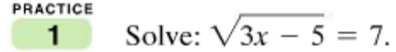

Solution
$${\left(\sqrt{3x-5}\right)}^{2}=7^{2}$$
$$=3x-5=49$$
$$3x=54$$
$$x=18$$

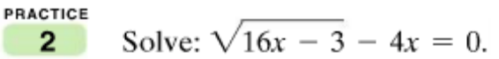

Solution
Squaring both sides
$${\left(\sqrt{16x-3}\right)}^{2}={\left(4x\right)}^{2}$$
$$16x-3=16x^{2}$$
$$\left(16x-16x^{2}\right)=3$$
- $x=\frac{1}{4}, or x=\frac{3}{4}$

Steps used to solve radical equations

- Isolate the radical expression.
- Square both sides of the equation: i.e. $${\left(\sqrt{16x-3}\right)}^{2}={\left(4x\right)}^{2}$$
- Once the radical is removed, solve for the unknown.
- Check all answers.
Practice 3
Solve the following equation by showing the steps required to solve a radical equation. Don’t forget to check all proposed solutions (STEP 4). Show your work
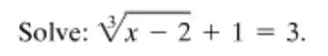
Solution
Isolate the radical expression.
$$\sqrt[3]{x-2}=2$$
cube both sides of the equation
$${\left(\sqrt[3]{x-2}\right)}^{2}=2^{3}$$
Once the radical is removed, solve for the unknown.
$$x-2=8$$
- $x=10$
Check all answers.
$\sqrt[3]{(10)-2}+1=10$,,, true

Practice 4
Solve the following equation by showing the steps required to solve a radical equation. Don’t forget to check all proposed solutions (STEP 4). Show your work
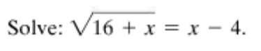
Solution
$${\left(\sqrt{16+x}\right)}^{2}={\left(x-4\right)}^{2}$$
$$=> 16+x=x^{2}-8x+16$$
$$=>x=0, or x=9$$
$$when x=0, false$$
When x=9, true hence $x=9$

Use the FOIL method to multiply the following.
- $\left(7-\sqrt{3x}\right)\left(7-\sqrt{3x}\right)$
Solution

$$7\left(7-\sqrt{3x}\right)-\sqrt{3x}(\left(7-\sqrt{3x}\right)$$

=$49-7\sqrt{3x}-7\sqrt{3x}+3x$
=$49-14\sqrt{3x}+3x$

- $(\sqrt{5x}+2)(\sqrt{5x}+2)$
Solution
$$=\sqrt{5x}\left(\sqrt{5x}+2\right)+2(\sqrt{5x}+2)$$
=$5x+2\sqrt{5x}+2\sqrt{5x}+4$
=$5x+4\sqrt{5x}+4$

Practice 5
Solve and check. Show your work.

$$\sqrt{8x+1}=\sqrt{3x}+2$$
Solution
$${\left(\sqrt{8x+1}\right)}^{2}={\left(\sqrt{3x}+2\right)}^{2}$$
=$8x+1=3x+4\sqrt{3x}+4$
- $x=3$
- $\sqrt{8(3)+1}=\sqrt{3(3)}+2$, True
$$Hence x=3$$

Graphing Calculator

Practice Problem 1:
Use the Intersect feature of your graphing calculator to find the solution to the equation
$$\sqrt{2x+8}=5$$

What is the point of intersection?

Solution

$$x=\frac{17}{2}, y=5$$

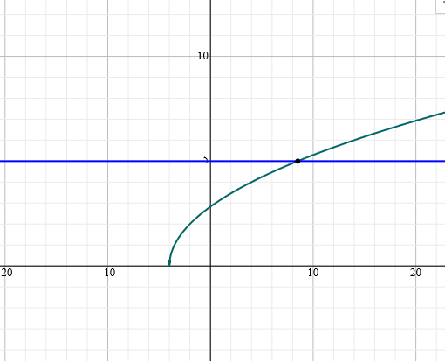

What is the solution to the equation?
$$x=\frac{17}{2}$$

Practice Problem 2:

Use the Intersect feature of your graphing calculator to find the solution to the equation
$$\sqrt{2x+5}=x+1$$

What is the point of intersection?

Solution

$$x=2 y=3$$

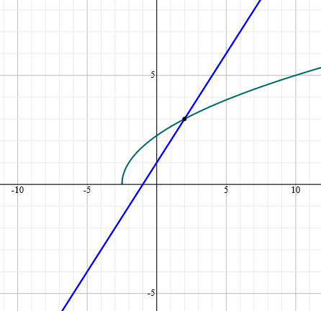

What is the solution to the equation?

$$x=2$$
.

Practice Problem 3:

Use the Intersect feature of your graphing calculator to find the solution to the equation

$$4-\sqrt{x}=5$$

What is the point of intersection?

Solution
$$x=1$$
$$y=15$$

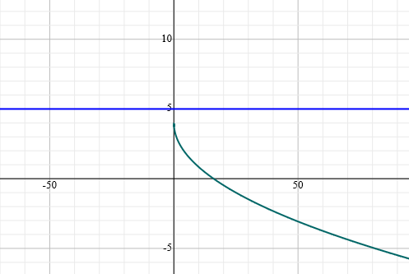

What is the solution to the equation?
There is no solution, $4-\sqrt{(1)}=5$,,,, IS FALSE

Objective 2
Using the Pythagorean Theorem

Pythagorean Theorem -a theorem in geometry: the square of the length of the hypotenuse of a right triangle equals the sum of the squares of the lengths of the other two sides.

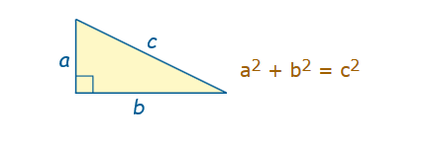

Practice 6
Find the exact length of the unknown leg of the right triangle, in terms of radicals. Simplify your answer

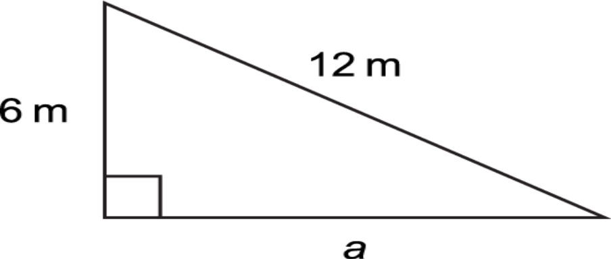
Solution
by Pythagoras theorem,
$${12}^{2}=6^{2}+a^{2}$$
$$=>144=36+a^{2}$$
$$108=a^{2}$$
$$a=\sqrt{108}$$
- $a≈10.39$

Practice 7
Keith Robinson bought two Siamese fighting fish, but when he got home, he found he only had one rectangular tank that was 12 in. long, 7 in. wide and 5 in. deep. Since the fish must be kept separated, he needed to insert a plastic divider in the diagonal of the tank. He already has a piece that is 5 in. in one dimension, but how long must it be to fit corner to corner in the tank?
Label and use the diagram to the right to help you solve the problem. One of the labels will be the unknown you are trying to find.
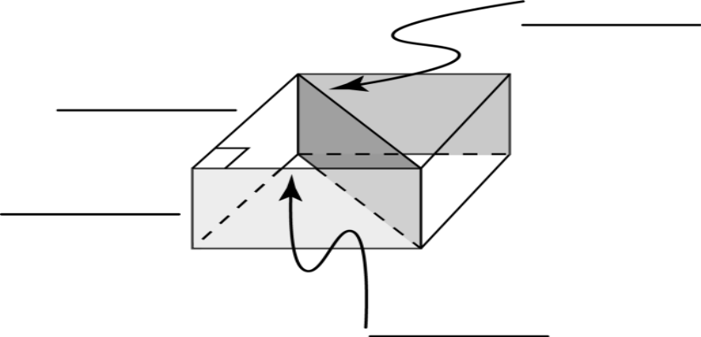

Solution
We want to find the hypotenuse
by Pythagoras theorem,
length = 12 in., width =7in,
$$c^{2}={12}^{2}+7^{2}$$
$$=>c^{2}=144+49$$
$$193=c^{2}$$
$$c=\sqrt{193}$$
- $≈13.89$
Thus the plastic divider must be 13.89 in long for it to fit corner to corner in the tank

Complete the Vocabulary, Readiness & Video Check Exercises on p. 629
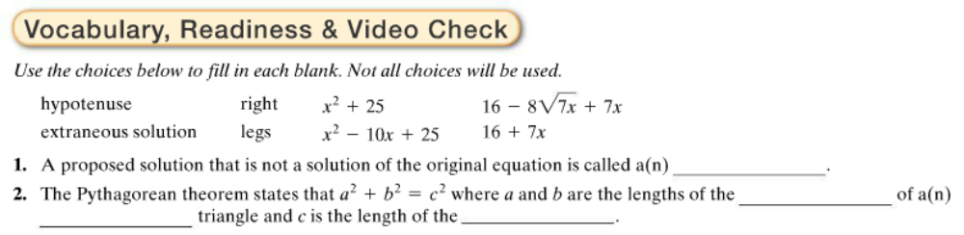
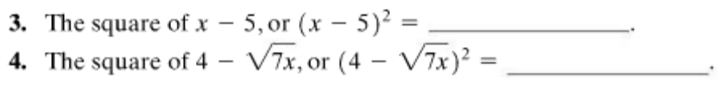

Answers
- Extraneous solution
- Legs,right,hypotenuse
- $x^{2}-10x+25$
- $16-8\sqrt{7x}+7x$

